**Adagio- AP (Accounts Payable)**

* Invoices tab
* Create New Batch
* Enter Vendor Code
* Enter Document # (Invoice # or Reference)
* Enter Invoice date
* Select Payment Terms

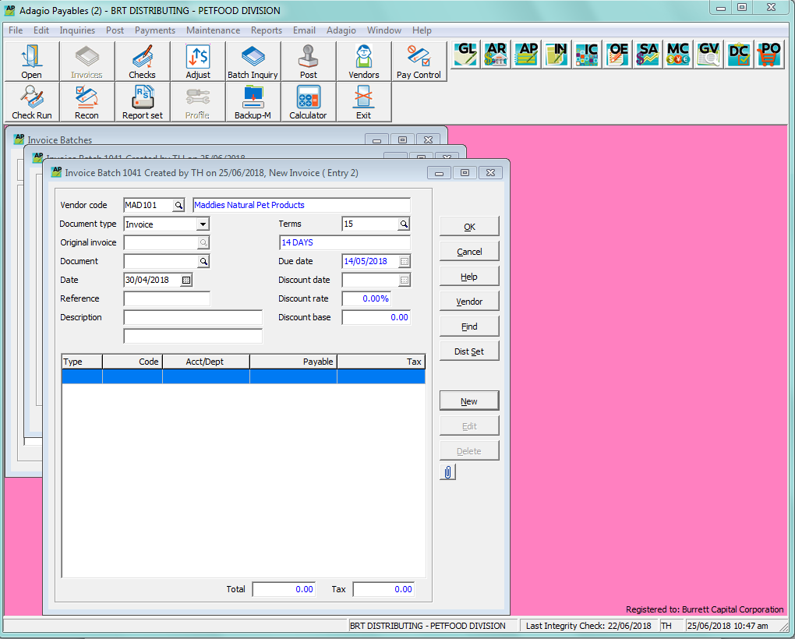

* Click on Blue Line or “NEW” button

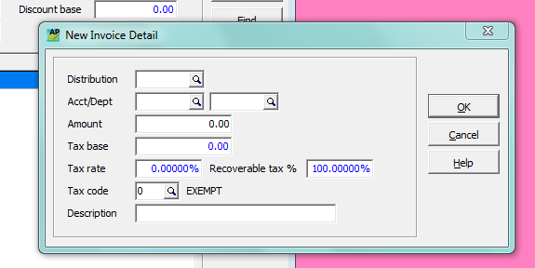

* Select expense account & department
* Enter the Net of Tax amount of invoice & click “OK”
* If there is tax (GST/HST) on the invoice enter/select the applicable HST account, then enter the HST payable amount, and click “OK” and close if nothing more to entered for this invoice.
* Stamp physical invoice posted
* Post Batch when finished